# TechShop Database Design & Data Modeling

## 1. ER Diagram

The following Entity-Relationship Diagram (ERD) showcases the database structure and relationships between entities in the TechShop system.

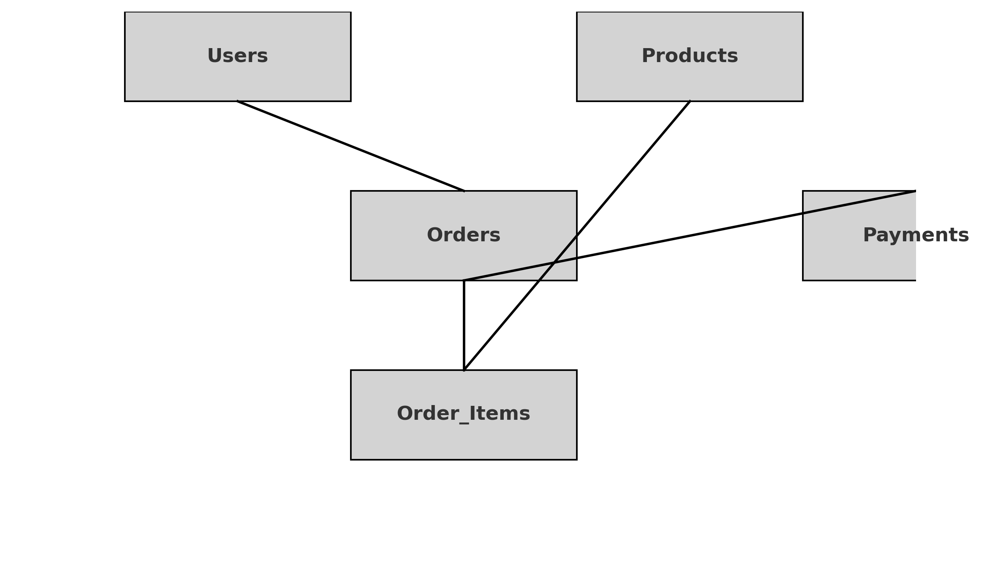

## 2. Logical & Physical Schema

The database consists of the following main tables with their respective attributes and keys.

### Users

* • UserID (PK)
* • Name
* • Email
* • PasswordHash
* • Role

### Products

* • ProductID (PK)
* • Name
* • Description
* • Price
* • StockQuantity

### Orders

* • OrderID (PK)
* • UserID (FK)
* • OrderDate
* • TotalAmount
* • Status

### Order_Items

* • OrderItemID (PK)
* • OrderID (FK)
* • ProductID (FK)
* • Quantity
* • Subtotal

### Payments

* • PaymentID (PK)
* • OrderID (FK)
* • PaymentMethod
* • Amount
* • PaymentStatus